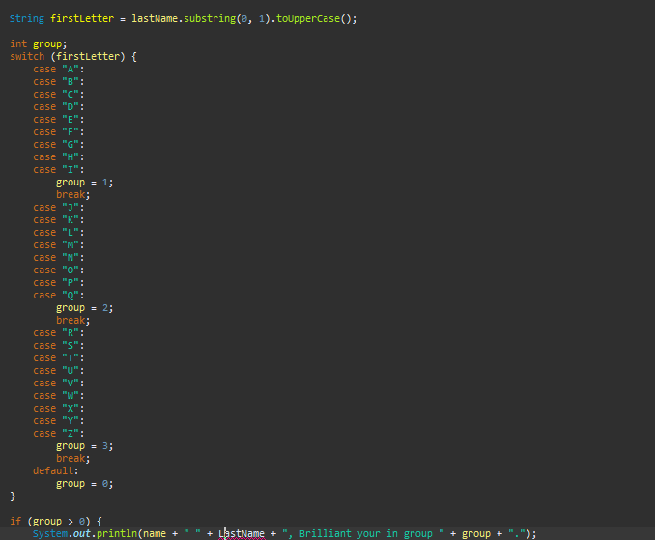

For this error I made a syntax error last name was a syntax error